PRESBYTERIAN CHURCH OF VICTORIA |  | 
CLERK OF ASSEMBLY  REV JOHN P WILSON  TELEPHONE: (03) 9650 9311  FACSIMILE: (03) 9654 5018  E-MAIL: office@pcv.org.au | OFFICE OF THE GENERAL ASSEMBLY  MEZZANINE LEVEL  156 COLLINS STREET  MELBOURNE VIC 3000  ABN 89 276 382 053

Presbytery Clerk
Presbytery of Melbourne East
PO Box 272
Hawthorn VIC 3122
17 October 2016

NB This is a replacement letter to the one sent 14 October 2016

Dear Presbytery Clerk,

There are a number of important matters to relate to your presbytery from the most recent sittings of the General Assembly. On behalf of the Assembly, I would be grateful if you gave each item attention in a timely manner.

Extracted from the Minutes, in the order of appearance:

1. Printing and distribution of the new PCV Code Book

Min. 83
Code and General Administration Committee
  - Regarding the PCV Code Revision Project:
  - Replace PCV Rules (chapters 1 – 7) October 2013 edition with PCV Rules (chapters 1 – 7) October 2016 edition.
  - Authorise printing of the October 2016 GAV Code Book in sufficient supply so that each member of the General Assembly, each employee of an Assembly committee, the PCV Law Agent, each member of the BIF/TC, each committee office bearer, each session clerk and deputy clerk, each board of management secretary and treasurer, each presbytery office bearer, and every member of the PCV who requests it may have a copy free of charge up to the end of January 2017.

To assist with the outworking of 1(b) above, and to eliminate postage costs, when the book is printed I will visit each presbytery clerk’s home with sufficient supplies for “each session clerk and deputy clerk, each board of management secretary and treasurer, each presbytery office bearer” for distribution at the following presbytery meeting.

I’d be grateful if you’d inform me of the exact number of session clerks (& deputies), board of management secretaries & treasurers, and presbytery office bearers in your entire presbytery bounds.

2. Encouraging ministers to take their accrued Long Service Leave

Min 91
Maintenance of the Ministry Committee
2. Direct presbyteries to encourage ministers to take accrued long service leave according to MMC regulations and to discuss how best to implement this.

This resolution seems to be self-explanatory.

3. New approach to Sites Reserve funds

Min 96
Ad Hoc Committee re: Sites Reserve
Final decision
The Assembly resolved to:
- Affirm the right of a congregation associated with a Sites Reserve Fund to direct the Board of Investment and Finance how to expend Fund monies, but only after the congregation has gained the necessary approval of Presbytery, or Presbytery and Assembly, to so use the monies:
- if the desired use is to cost over $100,000, approval from both the Presbytery of the bounds and Assembly is necessary;
- otherwise approval is only required from the Presbytery of the bounds.
- Instruct the Code Committee to prepare changes to the BIF regulations to reflect the intent of clause 1 (above) for both ‘Existing Congregations’ and ‘Deceased Congregations’ (where Presbytery becomes the directing body, with Assembly’s approval required if a proposal is over $100,000) in what is currently BIF Regulation 10.
- Request the Presbytery of the bounds to encourage a congregation associated with a Sites Reserve Fund to donate 20% of the annual Sites Reserve interest earned to another congregation or committee of the Presbyterian Church of Victoria (selected by the congregation) that is in need.

This resolution seems self-explanatory and you should notice that the onus for authorising requests for use of Sites Reserve Funds swings, more than previously, to the presbytery.

4. The need for an “Assistant to the Clerks”

Min 97
Clerkship Committee
2. In reference to GAV 2013, min 66.5 re: clerk’s succession planning, and as interim measures:
  - Create a new office of the Assembly called ‘Assistant to the Clerks’.
  - Fix his duty as to give assistance to the Clerk of Assembly and the Deputy Clerk of Assembly.
  - Declare that wherever a regulation specifies that ‘the Clerks’ are members of a committee by virtue of office, that regulation shall also include ‘Assistant to the Clerks’.
  - Declare that, should both the Clerk and Deputy Clerk of Assembly be incapacitated, the Clerkship Committee, under its regulation 3(f) may appoint the Assistant to the Clerks as Acting Clerk.
  - Declare that the Assistant to the Clerks, upon appointment, make the declaration of faithful duty, according to Rule 6.6.
  - Invite presbyteries to make nominations for this position, with names to be in the hands of the Clerk by 31 March 2017.
  - Direct the Clerkship Committee to interview the presbytery nominees, and to bring to the May 2017 Commission of Assembly the list of nominees and its recommended candidate for appointment to this office, together with a report outlining its reasons for this recommendation.
  - Authorise the 2017 Commission of Assembly to make the appointment, commencing 1 July 2017, with an annual honorarium half that received by the Deputy Clerk.
  - Direct the Clerkship Committee to review the performance of the appointee and report to the 2018 General Assembly with its recommendations for the continuance of the appointment or otherwise.

To assist with the outworking of 2(f) above, I invite presbyteries to make nominations, in writing, by 31 March 2017. Each nomination ought to include:
- A brief summary of the nominee’s ministry experience in the church.
- Reasons why presbytery believes the nominee is suitable for the position.
- Confirmation that the nominee is willing for his name to go forward.

5. Position of Moderator for 2017/18

In line with regulations, I invite presbytery to make up to two nominations for the position of Moderator-Designate of the General Assembly, 2017/18.

The nominations are due by 31 March 2017, and the election will be conducted at the Commission of Assembly, 2 May 2017. Please be sure that you include a note from your nominee that he is willing for his name to go forward.

With warm regards,

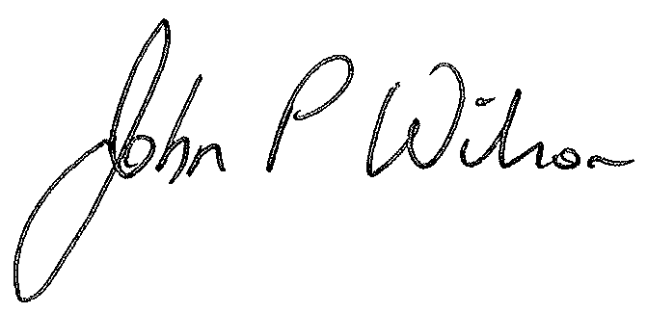
John Wilson
Clerk of Assembly

